Good day / Bad day
Describe what does a good day look like, what are the things that need to happen to make it a good day? What does a bad day look like?

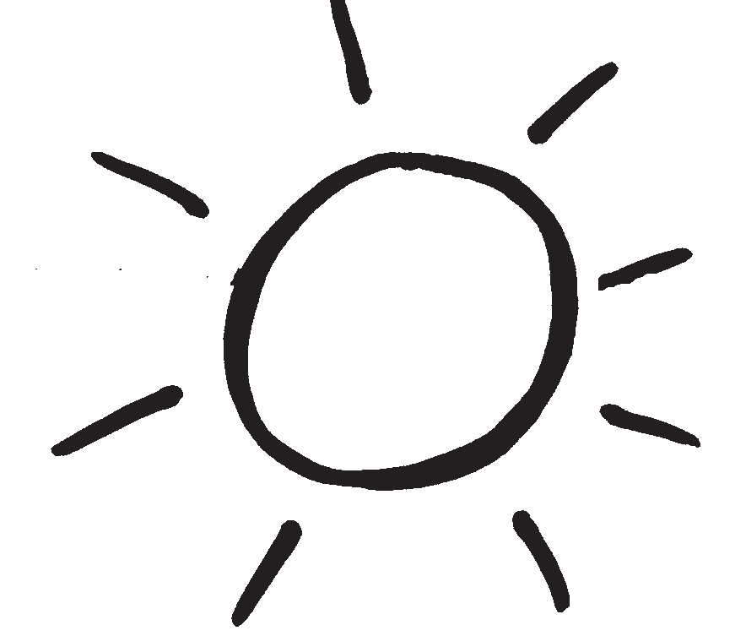  Good Day? | 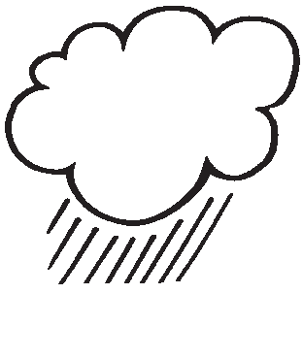  Bad Day?
What will it take to have more good days and fewer bad days?

